40 401 beams in a laser multi-beam nanostructuring is a new record
Dolni Brezany, 8/9/2021
The new record in multibeam laser nanostructuring, with respect to the number of laser beams simultaneously modifying the material surface, was reached due to the active scientific cooperation of HiLASE Centre of the Institute of Physics of the Czech Academy of Sciences with the Israeli company HOLO/OR Ltd.
Superhydrophobic surfaces and their potential industrial applications, including anti-icing, anti-corrosion, self-cleaning or air resistance surfaces, are the hot topics in the field of nanomaterials.
Although laser surface structuring, creating defined nanostructures, is a well-known method, it is not widely used in industry. Besides high investment cost in the required laser based machine, the speed of the process is main bottleneck. An answer to this demand seems to be multi-beam machining, which can offer an effective solution for the wider industrial use of lasers in this area, thus increasing the process productivity up to thousand times.
Scientists from both HiLASE Centre and HOLO/OR have discovered a method to efficiently nanostructure a large area using just a few laser pulses. "The principle is a unique combination of a high-energy, ultrashort pulsed laser system with an optical assembly, which focuses and splits the input beam into an ordered square matrix of 201x201 sub-beams.," explains Peter Hauschwitz, team leader of HiLASE Laser Micromachining Team. He further elaborates, "a squared area of 1mm² can thus be simultaneously structured with 40,401 sub-beams with a diameter of only 4.9 µm and productivity of more than 8 million microspots per second. In addition, a periodic nanostructure with a specific function is created within each of these microspots, e.g. to change the wettability of the surface."
The experimental setup included special prototype optics designed by HOLO/OR, i.e. Diffractive Laser Induced Texturing (DLITe) beam splitter, focusing optical elements and the unique HiLASE PERLA laser system, which has excellent beam quality and high pulse energy (up to 20 mJ at 1030 nm ) with a length of 1.7 ps. "DLITe is a brand new category of diffractive beam splitters focused on diffractive laser induction texturing and was developed by our company to texture large areas" says Natan Kaplan, CTO at HOLO/OR, adding "and we are proud that our equipment and scientists have helped to achieve such a significant record".
This achievement enables, for the first time, the industrial adaption of laser nanostructuring as an innovative method for rapid and economical production of superhydrophobic surfaces on a larger scale.
A detailed description of the experiment including the results can be found at
www.mdpi.com/2079-4991/11/8/1987
For more information, please visit www.hilase.cz

CONTACT FOR MEDIA
Marie Thunová | Leader of PR & Marketing | marie.thunova@hilase.cz | M: +420 702 235 039
About HiLASE Centre
HiLASE Centre (an acronym for High average power pulsed LASErs) is a scientific research centre of the Institute of Physics of the Czech Academy of Sciences. The main goal of the research centre is to develop new frontier laser technologies - diode (diode pumped solid state laser systems, DPSSLs) with high energy per pulse and high repetition frequency at the same time. HiLASE centre also tests the durability of optical materials (LIDT – Laser Induced Damage Threshold) and conducts research on strengthening material through laser shock peening, precision cutting, drilling, welding, micromachining and surface cleaning.
Stay in touch with us:
LinkedIn www.linkedin.com/company/hilase-centre
Twitter https://twitter.com/HiLASECentre
Facebook www.facebook.com/HiLASECentre
YouTube https://www.youtube.com/c/HiLASECentre

About FZU
The Institute of Physics (IOP) is a scientific workplace dedicated mainly to basic research and is part of the Czech Academy of Sciences (CAS). The main activity of IOP is scientific research in the field of physics, especially physics of elementary particles, condensed systems, solids, optics, plasma physics, and laser physics.
About HOLO/OR
HOLO/OR Ltd. (Est. 1989 by Israel Grossinger) develops designs and manufactures diffractive optical elements (DOEs) and micro-optical elements. HOLO/OR offers standard and tailor-made laser beam shaping and splitting products as required by customer and application, and is considered a world leader in their field.

Attachment:

The simple schematics of optical and micromachining configuration together with the texturing approach.
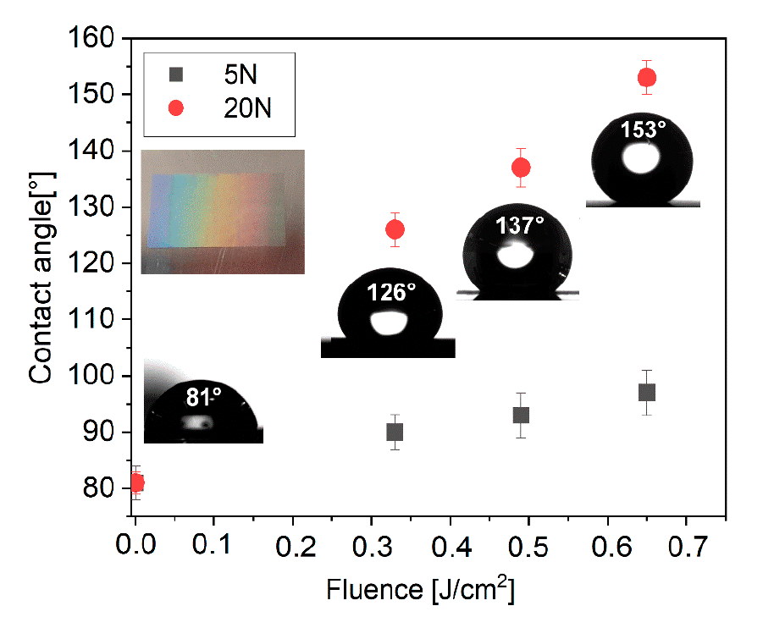
Contact angle evolution for samples stored in vacuum conditions for 6 h with insets of droplets on surface treated by 20 pulses and inset of the treated surface by 20 pulses demonstrating droplets on surface treated by 20 pulses and inset of the treated surface by 20 pulses demonstrating structural color due to diffraction depicts plane untreated surface on nanostructures. Fluence 0 J/cm² depicts plane untreated surface stored in vacuum.

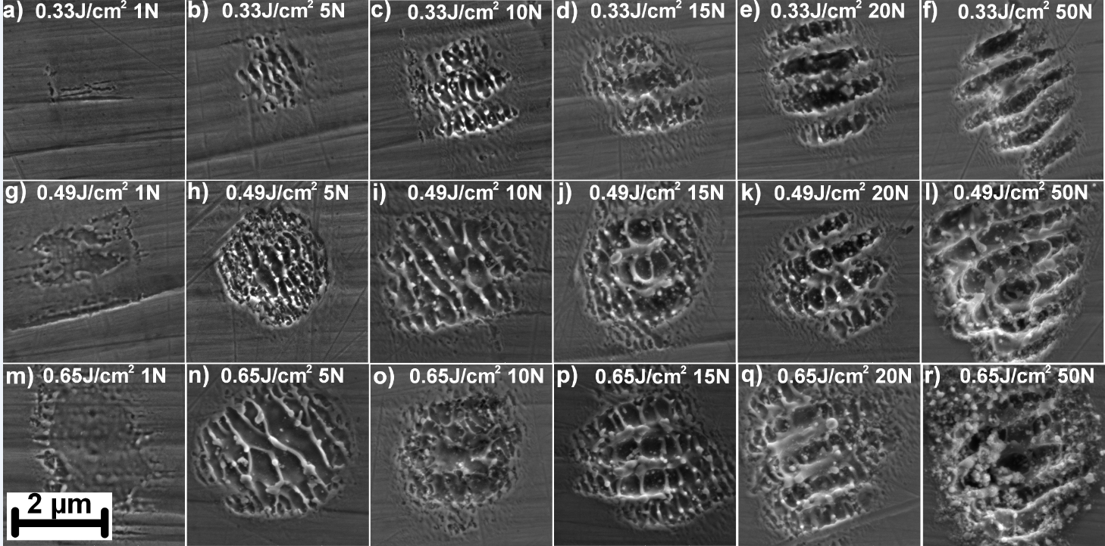
Evolution of nanostructures formed inside each microcrater in a dependency on applied fluence and number of pulses (N).
Download photography in high resolution from HERE.
Full paper describing the experiment with record „Towards Rapid Fabrication of Superhydrophobic Surfaces by Multi-Beam Nanostructuring with 40,401 Beams“ is HERE.

