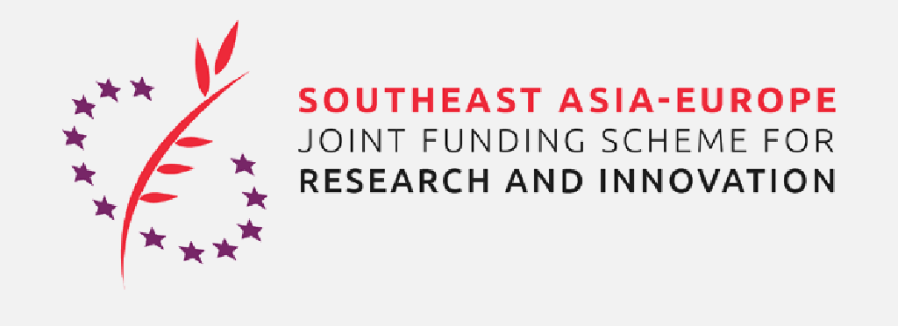

PROJECT PROPOSAL DETAILS

Project Proposal Details must be submitted electronically (signed, scanned copy), to the e-mail address of the contact person (see below) by
- 15 December 2020 − proposals in the thematic areas of Infectious Diseases (incl. COVID-19) and Nanotechnologies;
- 15 January 2021 − proposals in the thematic areas of Digital Health (incl. Infectious Diseases) and Bioeconomy (incl. Application of ICT-based Technologies).

Project Proposals for the SEA-Europe JFS must be submitted simultaneously in a way described in the Call for Proposals, available at https://www.sea-eu-jfs.eu/calls.

Contact Person:
Alena ŽOCHOVÁ
Division of International Cooperation
Kancelář Akademie věd ČR
Address: | Národní 1009/3, 117 20 Praha 1
E-mail: | zochova@kav.cas.cz
Tel: | +420 221 403 566

Complete all white fields in English.
Programme: | SEA-Europe JFS

Thematic area:
Period: | 7/2021 – 6/2024

CAS Institute |  | Czech Principal Investigator
Name: | Choose an option | Name:
Address: |  | E-mail, Tel:

Project Title:

Project leader for Southeast Asia

Name:

Affiliation:

Project leader for Southeast Asia/Europe

Name:

Affiliation:

Other project partners

Name:

Affiliation:
Add lines if necessary.

Abstract

(max. 1 100 characters incl. spaces)

Summary of Research Plans of the Czech Project Partner(s), their Implementation and Justification of Proposed Collaboration.

(max. 1/2 page)

Description of the Czech Project Team – Involvement of Young Researchers is Mandatory

(max. 1/2 page)

CV of the Czech Principal Investigator

(max. 1 page)

Date: | Insert the date | Date: | Insert the date
Signature of Czech Principal Investigator: |  | Stamp and Signature of CAS Institute Statutory Authority:

