 |  | 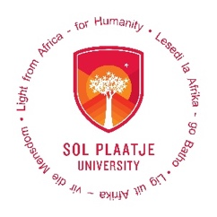


PRESS RELEASE
Prague, 29 June 2026
Czech and South African archaeologists search for traces of the persecution of German civilians in Africa
Archaeologists from the Institute of Archaeology of the Czech Academy of Sciences in Prague and the University of West Bohemia in Pilsen, together with colleagues from Sol Plaatje University in Kimberley, have been investigating the remains of the Andalusia internment camp near the town of Jan Kempdorp. In the 1940s, the camp was used to intern German civilians who, for various reasons, found themselves in British-controlled territories south of the equator.
South-West Africa (now Namibia) and East Africa (now Tanganyika, Rwanda, and Burundi) were German colonies until 1919. The German population there formed a minority but constituted an economically and politically privileged elite. Following the 1919 Versailles Conference, which, along with the First World War, brought an end to the German colonial empire, these farmers, miners, craftsmen, and merchants came under increasing British political and cultural pressure. After the outbreak of the Second World War, adult men from this community were interned in several detention facilities as potentially hostile foreigners. One of these, Camp Andalusia, was located in central South Africa near the town of Jan Kempdorp. Approximately 1,200 men were interned there.
“The German colonists were joined by German citizens who had resided in British territories in southern Africa, as well as by the crews of seized German merchant vessels. The events of 1946–1948 that followed the end of the war are also familiar from the European context. Although the interned Germans had not been directly involved in the conflict, a wave of forced repatriations followed, affecting entire families who were returned to Germany on the grounds of perceived collective political unreliability.”
Jan Hasil, Institute of Archaeology of the Czech Academy of Sciences, Prague, v.v.i.
Using historical plans and aerial photographs, Czech archaeologists, together with their South African colleagues, rediscovered, after eighty years, the building remains of the camp, including several dozen bungalows, out of the original two hundred. These standardised prefabricated corrugated-iron structures each accommodated six internees. Their austere military appearance stands in marked contrast to the small gardens established around them, constructed from local stone and other readily available materials, where internees cultivated fruit, vegetables, and flowers. This aspect of camp life is also documented in a series of watercolours created by camp residents, which are preserved at the Museum Café in the Border Hotel, Jan Kempdorp. The research adopts a transdisciplinary approach, integrating a variety of source categories and datasets.
“The remains of individual buildings and elements of the camp infrastructure were documented using a drone and modern surveying methods, ensuring centimetre-level measurement accuracy. The resulting outputs will include orthophoto maps of the entire camp site and detailed 3D models. In a sense, it is as though we have brought Camp Andalusia to Europe.”
Petr Hasil, University of West Bohemia in Pilsen
The research is being conducted as part of the OP JAK project The Land Gone Wild: Archaeological and Transdisciplinary Research on Resilience Strategies in the 20th Century, supported by the Ministry of Education, Youth and Sports of the Czech Republic and co-financed by the European Union. The aim of researchers from the Institute of Archaeology and the University of West Bohemia is to gain archaeological insights into internment facilities and systems of state repression in the 20th century from a global perspective. Their research encompasses sites ranging from the Soviet Gulag in Kazakhstan, through Nazi concentration and labour camps in the Czech Republic and Poland, and sites associated with forced labour during the communist period in the Czech Republic, to a British internment camp in South Africa. The researchers seek to understand these sites as a specific type of settlement within the landscape, as instruments of social engineering, as spaces of everyday life and cultural expression for internees, and, last but not least, as places of memory. Within this broader comparative framework, South Africa also offers a longer historical perspective on internment facilities, extending back to the South African War of 1899-1902, as well as research interest in such sites.
“Understanding camps through the lens of conflict archaeology and conflict heritage is key to our knowledge of the shaping of the modern era. Societies were shaped by war, mass violence, state terror and internment, which aftershocks still shape and drive current and lived realities. The site at Andalusia in turn links to the South African War (1899-1902) black forced labour camps near Jan Kempdorp and Kimberley and the Black and Boer concentration camps in our region and across South Africa. Such conflict sites in turn integrate into a global narrative as expressed through our shared project and interconnected humanity.”
Dr. Garth Benneyworth, Sol Plaatje University, Kimberley

Contact details:
Mgr. Jan Hasil, Ph.D. Dr. Garth Benneyworth (FRHistS)
Department of Historical Archaeology Department of Heritage Studies
Institute of Archaeology of the CAS, Prague Sol Plaatje University Kimberley
+420 605 364 215 +27 (0) 76 216 9463
hasil@arup.cas.cz garth.benneyworth@spu.ac.za



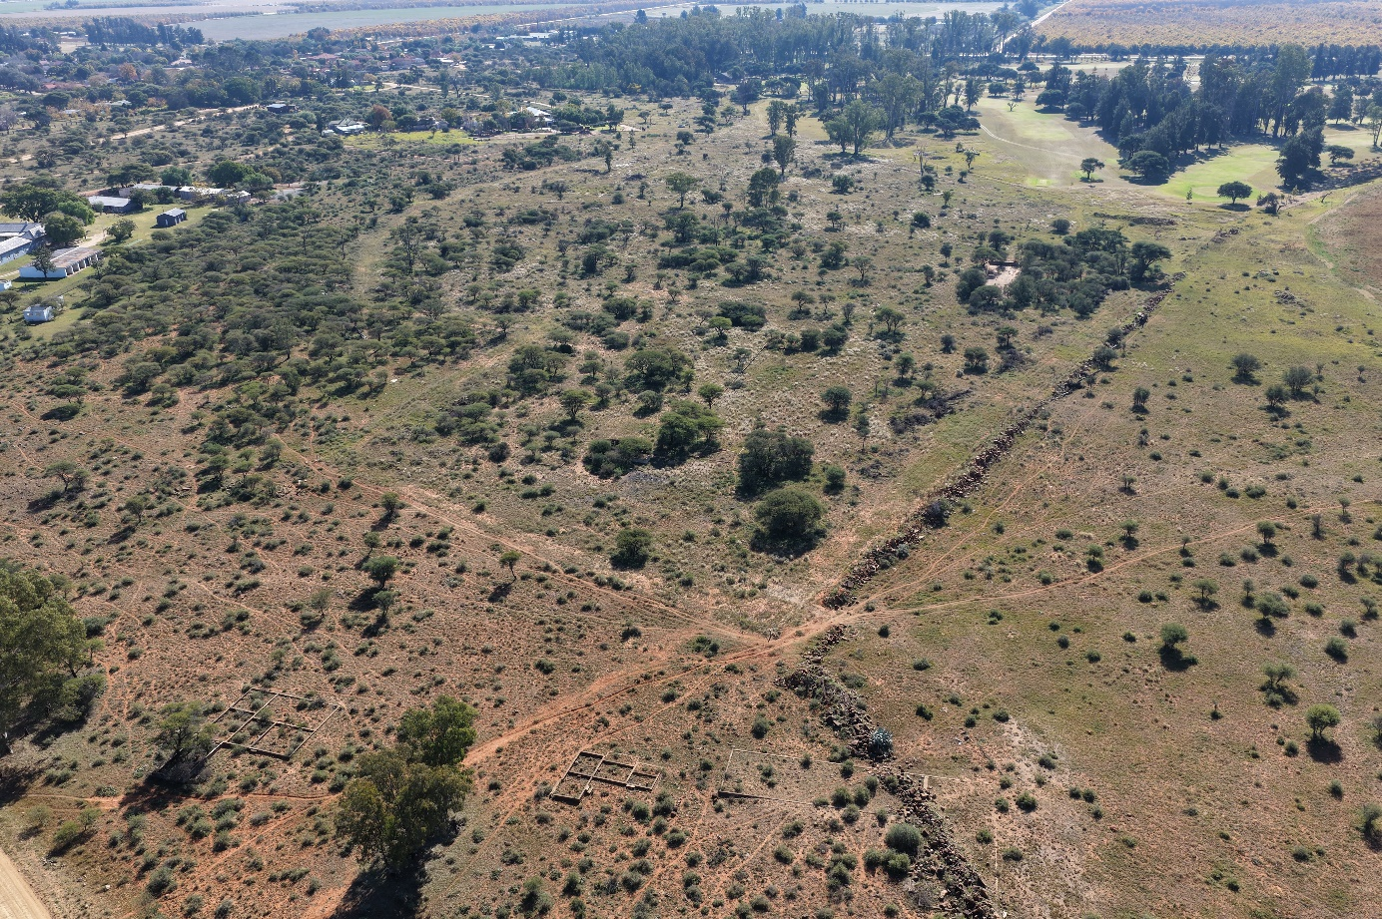
Fig. 1. Camp Andalusia, general view. In the foreground, the foundations of buildings used by the guard detachment are clearly visible (photo by P. Hasil).
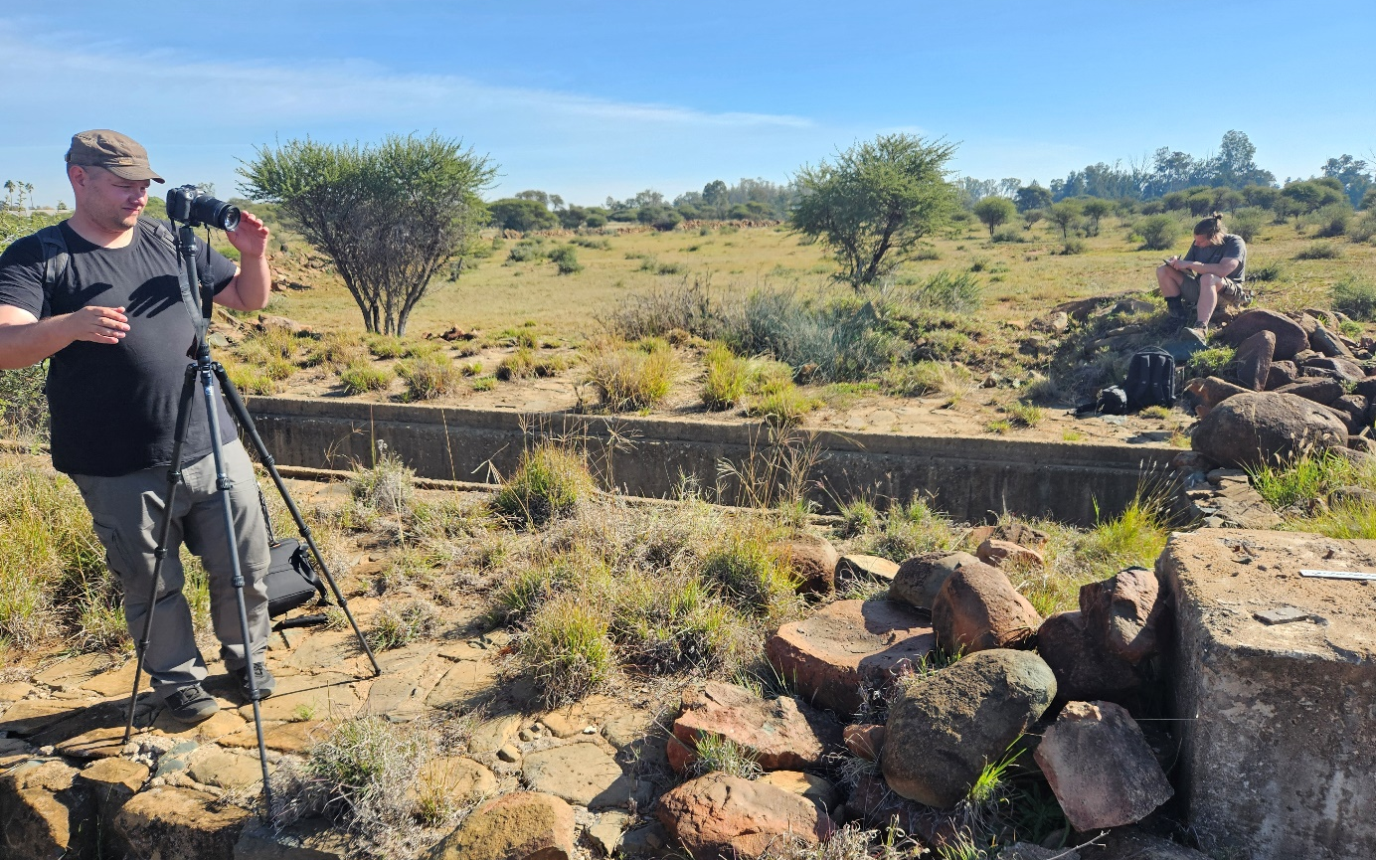
Fig. 2. Researchers from the Institute of Archaeology of the Czech Academy of Sciences and the University of West Bohemia conducting field documentation (photo by V. Podhrázský).
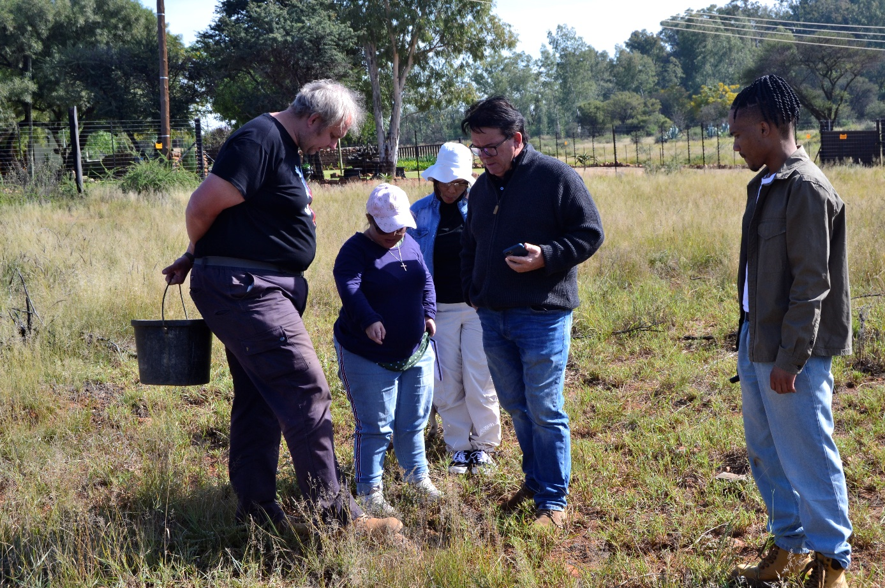
Fig. 3. Jan Hasil (left) and Garth Benneyworth discussing the find context with students from Sol Plaatje University (photo by S. Berry).
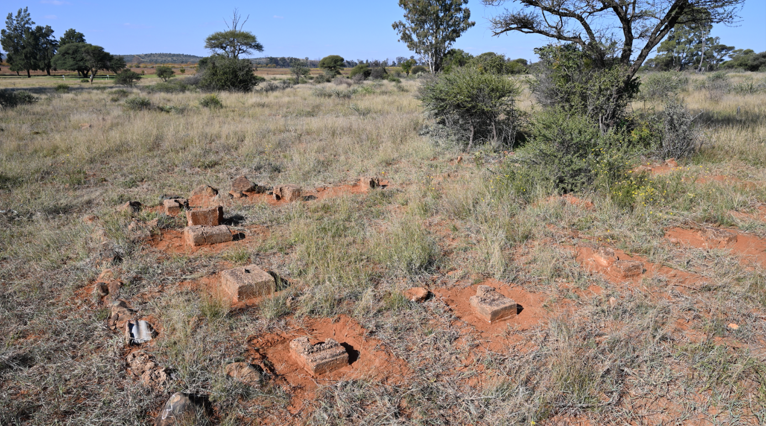
Fig. 4. Exposed foundations of one of the two hundred bungalows that provided accommodation for a group of six internees (photo by J. Hasil).
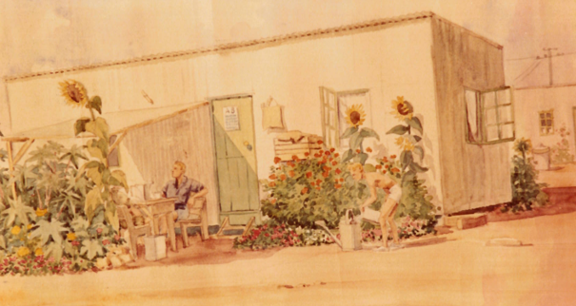
Fig. 5. A six-man bungalow depicted in a watercolour created in the Andalusia internment camp (collection of the Museum Café).

