**Hidden Parasites Could Threaten the Health of Endangered Mountain Gorillas**

***New international research conducted by a team including scientists from the Institute of Vertebrate Biology of the Czech Academy of Sciences (IVB CAS), Gorilla Doctors, and the Dian Fossey Gorilla Fund, with support from the Rwanda Development Board and Uganda Wildlife Authority, reveals long-term shifts in parasite communities that may help explain rising health threats faced by mountain gorillas.***

A unique study, published in *Biological Conservation*, examined dynamics of parasitic infections in both populations of endangered mountain gorillas. The motivation behind the research was to explain the rising occurrence of gastrointestinal disease in mountain gorillas, including fatal cases. Necropsies of deceased individuals revealed pathological changes consistent with gastric nematode infections.

The researchers analyzed parasitic DNA from a rare collection of mountain gorilla fecal samples spanning nearly two decades, specifically collected in 2001 and 2018 from gorillas in Rwanda’s Volcanoes National Park in the Virunga Massif and Uganda’s Bwindi Impenetrable National Park. They focused on strongylid nematodes, a group of helminth parasites that infect the stomachs and intestines of many vertebrates. These parasites pose health risks not only to humans and domestic animals but also to wildlife, including great apes. “*In cases of heavy infestation or shifts in community composition, strongylids can cause severe illness or even death and these data are helping us deliver best-achievable in situ veterinary medicine to wild mountain gorillas,*” explains Tierra Smiley Evans, Chief Veterinary and Scientific Officer at Gorilla Doctors.

Because adult worms are rarely accessible and parasite eggs in feces cannot be reliably identified to species or genus using traditional microscopy, the team employed high-throughput sequencing (HTS), a sophisticated DNA-based technique, to determine which strongylids were present and how their communities had changed. “*This kind of long-term epidemiological data is extremely rare for endangered species*,” adds Winnie Eckardt, Senior Manager of Primate Research at the Dian Fossey Gorilla Fund in Rwanda. *“It allows us to see not just what parasites are present today, but how things have shifted over time and that’s critical for understanding disease risk.”*

**Uncovering Hidden Threats to Mountain Gorillas**

The study revealed that the two isolated mountain gorilla populations harbor distinct strongylid communities. In Bwindi, gorilla strongylid communities include genera that are rare or absent in the gorillas of Volcanoes National Park. These differences have remained consistent over time and are likely linked to differences in ecology between populations and potential exposure to chimpanzees, which are absent in Volcanoes National Park. In contrast, Volcanoes National Park gorillas, especially those living between Mount Karisimbi and Mount Bisoke, where gastrointestinal disease has been most frequently reported, have shown marked shifts in their strongylid communities. The most notable change is a sharp rise in *Hyostrongylus*, a parasite typically associated with gastritis in pigs. Once low in abundance, it is now dominant, but only in the gorilla groups living in areas where gastrointestinal illness and deaths have been documented. “*This shift shows how ecological imbalance can tip the scales toward disease, even with parasites that have long been present at low levels*,” says lead author Bethan Mason, researcher from the Primate Symbiont Ecology Research Group at the IVB CAS.

Importantly, the team found no evidence for the introduction of an entirely new parasite species. Instead, the threat appears to stem from dynamic changes in abundance within existing communities, a phenomenon known as “community turnover.” This suggests that environmental stressors and ecological changes may be tipping the balance and allowing some parasites to outcompete others. “*This pattern echoes what we see in livestock kept at high densities, where parasite buildup and reinfection cycles lead to serious health problems*,” continues Bethan. “*The question is whether we’re seeing something similar in wild gorillas that now live in relatively small, increasingly crowded habitats*.”

**The Importance of Historical Samples in Research**

One of the first biobanks created specifically for conservation was established in the 1970s, guided by the motto: “*You must collect things for reasons we don’t yet understand.”* Nearly fifty years later, that philosophy remains highly relevant. Biobanks enable researchers to explore questions that had not yet been formulated at the time of sample collection and to apply newly developed molecular techniques to historical material. “*Historical samples from biobanks are invaluable in this research because they enable retrospective analyses and the application of modern molecular techniques. Biobanks are key to understanding long-term trends in disease ecology*,” says Julius Nziza, head veterinarian for Rwanda with Gorilla Doctors. “*Gorilla Doctors’ nearly 40 years of samples allow for robust, long-term research that contributes to both our understanding of population health trends as well as conservation health management.”*

Combining decades of field-based health and conservation records with cutting-edge DNA techniques, the research highlights the benefits of integrated scientific approaches. “*It clearly demonstrates how multidisciplinary cooperation and long-term data are essential for understanding disease dynamics and building effective conservation strategies. The findings can help guide sustainable management of endangered species and the unique ecosystems they inhabit*,” says Richard Muvunyi, country head wildlife veterinarian at the Rwanda Development Board.

The study represents the latest product of a long-standing collaboration between Czech, Rwandan, and Ugandan scientists and conservationists. It provides rare insights into the hidden world of gastrointestinal parasites and the role they play in the health and survival of one of the world’s most iconic species.

Link to the articles: <https://doi.org/10.1016/j.biocon.2025.111319>

**Contacts:**

**Bethan Mason**Institute of Vertebrate Biology of the Czech Academy of Sciences

[mason@ivb.cz](mailto:mason@ivb.cz)

**Radka Valterová**Institute of Vertebrate Biology of the Czech Academy of Sciences  
PR & Communications  
[valterova@ivb.cz](mailto:valterova@ivb.cz)

**Amy Bond**Gorilla Doctors

Chief Communications Officer

abond@gorilladoctors.org

**Erika Archibald**

Dian Fossey Gorilla Fund

Communications Specialist

earchibald@gorillafund.org

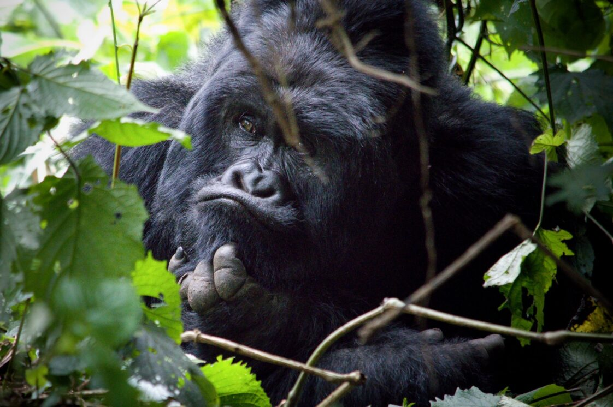*Male mountain gorilla from the population living in the Volcanoes National Park, Rwanda (photo credit: IVB CAS).*

Obsah obrázku venku, savec, rostlina, Gorila horská

Obsah generovaný pomocí AI může být nesprávný.

*Group of gorillas from the population in the Volcanoes National Park, Rwanda (photo credit: IVB CAS).*

*Strongylid nematode copulatory bursae, key for identification of adult worms and used by the parasite during reproduction to anchor the male and female*Obsah obrázku bezobratlý, Organismus, Mořští bezobratlí, Plankton

Obsah generovaný pomocí AI může být nesprávný. *together (photo credit: IVB CAS).*