**The Earth Prize 2025 on Earth Day: Teen duo from Slovakia and Czechia named Global Winner for clean water solution**

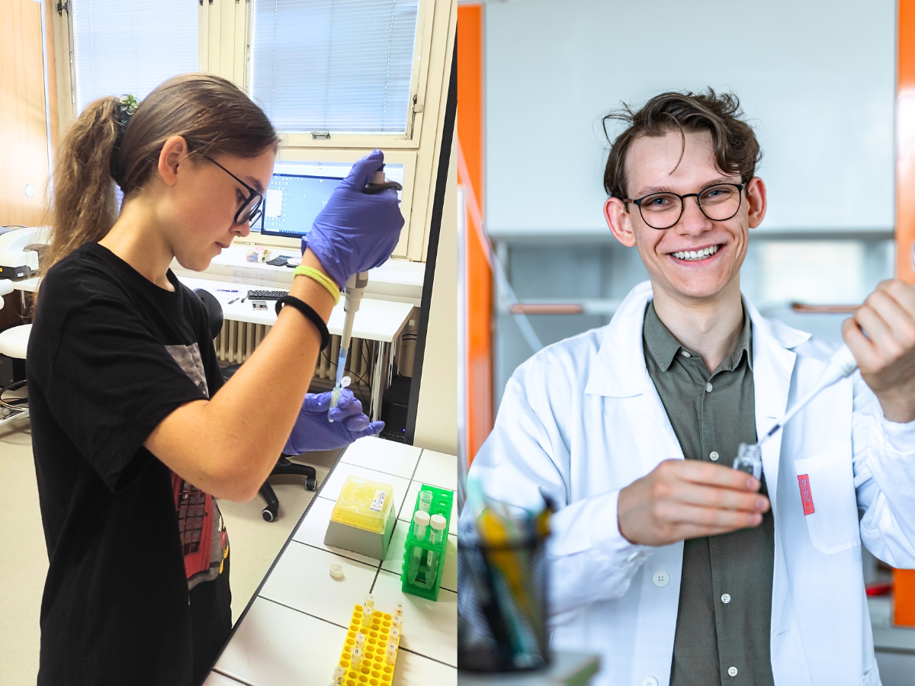

*More images available* [*here*](https://drive.google.com/drive/folders/1ceqrShK1ZZPZMtAHaJnOvgx4zd_NCigC?usp=drive_link)

* The Earth Prize is the world’s largest environmental competition for 13-19-year-olds, offering mentorship and $100K in funding
* The Global Winner is a duo of teen climate scientists from Czechia and Slovakia: Tomáš Čermák (18) and Anna Podmanická (19)
* They developed a groundbreaking water purifier called ‘PURA’, using light and plasma to combat pollutants and antibiotic resistance
* Around 16,000 people voted last week to decide the Global Winner out of seven Regional Winners from every continent
* PURA is the first winner of The Earth Prize to come from Slovakia or Czechia

Today, on Earth Day, [**The Earth Prize 2025**](https://www.theearthprize.org/) has named its **Global Winner**: an exceptional teen duo from Czechia and Slovakia. 18-year-old Tomáš Čermák and 19-year-old Anna Podmanická have developed PURA, a breakthrough **water purification** technology that uses light and plasma to remove pollutants and fight antibiotic resistance. Notably, PURA is the first-ever winner of The Earth Prize from **Slovakia or Czechia.**

Last week, nearly **16,000 people cast their votes** to select the Global Winner from seven inspiring Regional Winners representing every continent: North America, Africa, Asia, Central and South America, Oceania and Southeast Asia, Europe, and the Middle East. Representing the Regional Winner for Europe, PURA had already received **$12.5K** to scale their solution.

The Global Winner announcement was made today during [The Earth Prize 2025 Awards Ceremony](https://www.youtube.com/watch?v=S1v7X9tCdNI). PURA will also now receive a sustainably crafted “100-year” flag to be flown at their schools - an enduring symbol of youth-led climate innovation. Reflecting on their win, 18-year-old Tomáš Čermák and 19-year-old Anna Podmanická shared: *“This is just the beginning of our journey. Being named Global Winners of the The Earth Prize elevates our research to a global platform in the fight against water pollution. More importantly, it fuels our mission to raise awareness about the threat of contamination with drugs and antibiotics in our water. Together with The Earth Foundation, we aim to inspire more young innovators to take action and solve the problems of our world".*

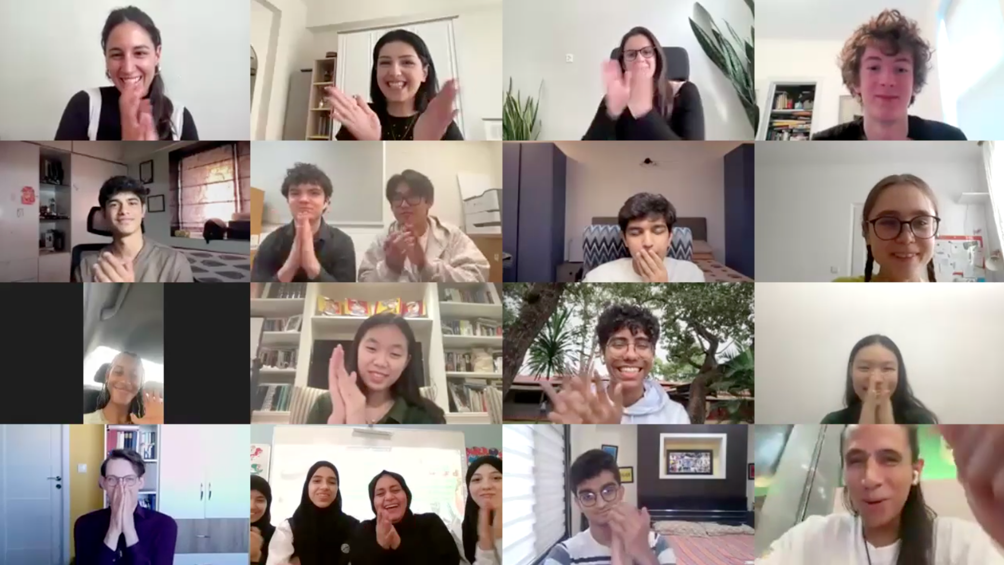

*PURA was named Global Winner during today’s Award Ceremony on Earth Day 2025. More images available* [*here*](https://drive.google.com/drive/folders/1ceqrShK1ZZPZMtAHaJnOvgx4zd_NCigC?usp=drive_link)

PURA was designed to address one of the world’s most urgent but often overlooked environmental threats: the **contamination of water systems with antibiotics and resistant bacteria**, particularly from hospitals, farms, and industrial wastewater. With antibiotic resistance projected to claim [10 million lives](https://www.who.int/news/item/29-04-2019-new-report-calls-for-urgent-action-to-avert-antimicrobial-resistance-crisis) annually by 2050, PURA’s mission is both timely and critical.

Tomáš (autism advocate and first high school researcher at the Institute of Plasma Physics, Czech Academy of Sciences), teamed up with Anna (a prize-winning young scientist from Slovakia selected for University of Oxford summer programme). Drawing from their individual research, the duo merged **photocatalysis** and **cold plasma** (AC corona) to create a novel two-step system that effectively removes pollutants and antibiotic-resistant bacteria.

While these technologies have been studied independently, PURA’s combined approach is **entirely new**. Their early prototypes have already shown the ability to purify small quantities of water, making them ideal for household use. Now, with support from The Earth Prize, the team is working on a **next-generation prototype** capable of treating dozens of litres of water, bringing PURA closer to large-scale impact.

*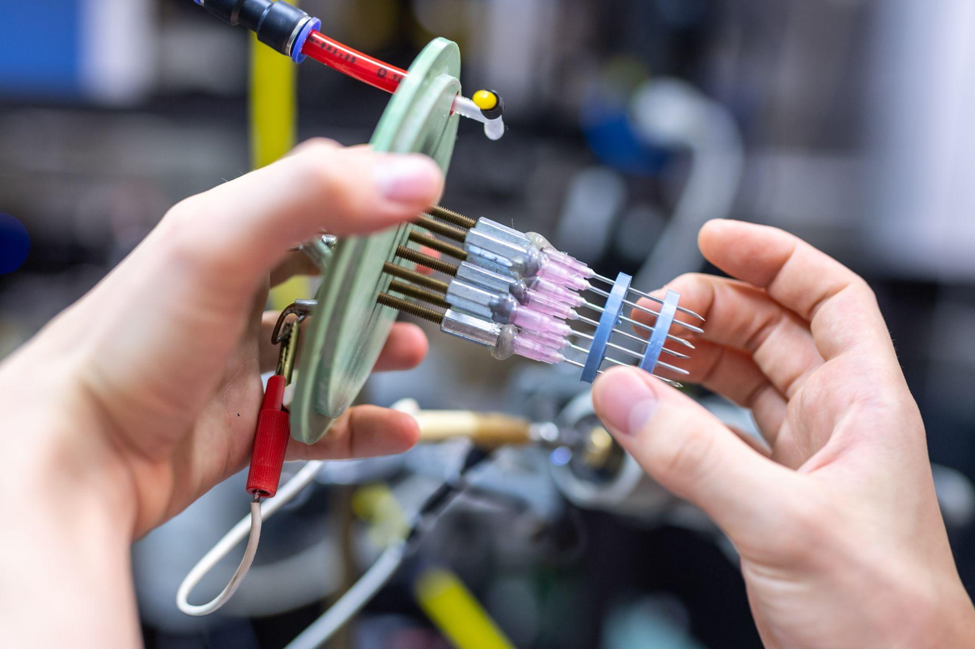  
Image by Jana Plavec, Czech Academy of Sciences*. *More images available* [*here*](https://drive.google.com/drive/folders/1ceqrShK1ZZPZMtAHaJnOvgx4zd_NCigC?usp=drive_link)

The long-term vision is to scale the easy-to-integrate technology for use in **wastewater treatment plants** (WWTPs), tackling resistance at its source. This energy-efficient, cost-effective solution could transform water purification and ensure a healthier future.

[The Earth Prize](https://www.theearthprize.org/) aims to empower the next generation with all the tools they need to develop their **eco solutions for real life impact**, including one-to-one mentoring, learning resources and funding of $100K for the winning teams to scale up. Since 2021, The Earth Prize has reached over **15,000 young people across 160 countries and territories**, and **awarded $500K** to the top teams.

Previous applicants have garnered **global media attention** in outlets such as [Forbes](https://www.forbes.com/sites/erikkobayashisolomon/2025/03/20/high-schoolers-offer-hope-for-a-post-climate-future/), [Business Insider](https://www.businessinsider.com/teens-win-50000-earth-prize-flood-forecasting-model-2024-8), [EuroNews](https://www.euronews.com/green/2024/07/11/i-feel-angry-about-climate-change-meet-the-turkish-teens-channelling-their-rage-into-solut), [Positive.News](https://www.positive.news/society/good-news-stories-from-week-10-of-2024/) and [UN Today](https://untoday.org/the-earth-prize-2024-finalists-focus-on-un-sdgs-6-12-and-15/), and continue to scale up their solutions after the competition has ended. For instance, team Delavo (Winners of The Earth Prize 2023), who invented a [cutting-edge filter](https://www.theearthprize.org/the-earth-prize-2023) that recycles up to 90% of toxic laundry waste water, partnered with a national manufacturer and applied for a patent to make their solution a reality.

[The Earth Prize](https://www.theearthprize.org/?utm_source=presskit&utm_medium=email&utm_id=earthprize2024) was started by [The Earth Foundation](https://www.earth-foundation.org/), a Swiss non-profit organization based in Geneva, as a way to **empower and educate young people** to tackle environmental challenges. As young people live through and observe extreme weather events such as the LA wildfires, many are mobilised to act - choosing to create solutions for our planet rather than march in protest.

A [recent study](https://www.cbsnews.com/news/climate-change-anxiety/) showed that **59% of youth** and young adults are **very or extremely worried about climate change**, and more than **45%** said their feelings about climate change negatively affected their daily life and functioning.

**Peter McGarry, Founder of The Earth Foundation**, commented on this year’s Global Winner: “*PURA’s selection as the Global Winner of The Earth Prize 2025 is a powerful reminder of what young minds can achieve. With PURA, Tomáš and Anna have combined scientific excellence with a deep sense of responsibility, offering a solution that could transform the health of both people and planet. Their work is exactly the kind of innovation The Earth Prize was created to elevate, and we are proud to support their journey.”*

**About The Earth Foundation**The Earth Foundation is a non-profit organization based in Geneva, Switzerland, dedicated to inspiring, educating, mentoring and empowering students and young entrepreneurs to address environmental changes with innovative ideas. The Earth Foundation was established as a result of the 2019 rallies organized by students to raise environmental awareness. This passion to fight for climate change inspired the creation of their flagship initiative, The Earth Prize—the world’s largest environmental competition and 'ideas incubator' for young people. The competition aims to inspire and empower the next generation of environmental innovators, supporting participants with all the tools they need to develop their eco solutions for real life impact, including one on one mentoring, learning resources and $100,000 funding for the winners. To learn more about The Earth Foundation visit: <https://www.earth-foundation.org/>. To learn more about The Earth Prize visit: <https://www.earth-foundation.org/earthprize/>.

* Previous coverage: [Forbes](https://www.forbes.com/sites/erikkobayashisolomon/2025/03/20/high-schoolers-offer-hope-for-a-post-climate-future/), [Business Insider US](https://www.businessinsider.com/teens-win-earth-prize-built-salt-powered-refrigerator-2025-4), [Business Insider Africa](https://africa.businessinsider.com/local/lifestyle/17-year-old-nigerian-girl-turns-climate-dreams-into-dollar125k-reality-as-she-bags/whg7d0p#), [EuroNews](https://www.euronews.com/green/2024/07/11/i-feel-angry-about-climate-change-meet-the-turkish-teens-channelling-their-rage-into-solut), [Positive.News](https://www.positive.news/society/good-news-stories-from-week-10-of-2024/), [UN Today](https://untoday.org/the-earth-prize-2024-finalists-focus-on-un-sdgs-6-12-and-15/), [Yahoo!](https://www.yahoo.com/tech/teens-invent-remarkable-device-while-180000437.html?guccounter=1&guce_referrer=aHR0cHM6Ly93d3cubGlua2VkaW4uY29tLw&guce_referrer_sig=AQAAACajAqVc1qLdlPrmGmBTgWxQJJ1sGYB9iCP7LSnZLhNf-jI_R2XEYebB4kY7wvfDrQxZLE8b4AFCLQkIcnM_DWjUOK-boXl7NcD1eC4c_SKaad3lzNQ2p6LsKJT9bf9BAREYxwZMRSG_trwh0D3H6tXcjI-MVORLVHbAB73GZn1K), [The Cool Down](https://www.thecooldown.com/green-tech/floodgate-app-high-school-students/)
* Press contact: Charlotte Tucker, [charlotte@earth-foundation.org](mailto:charlotte@earth-foundation.org)