 | 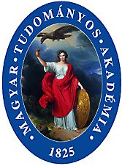 | 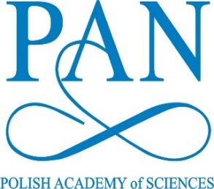 | 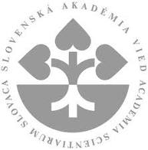

Visegrad Group Academies Forum
Liblice,
11-13 September 2018

List of participants

Hungarian Academy of Sciences:

Prof Mihály Pósfai, member of the Presidium
Mr Gergely Bőhm – Director, Department for International Relations
YRA Laureate: Dr Bence Péterfi

Polish Academy of Sciences:

Prof Jerzy Duszyński – President
Prof Elżbieta Frąckowiak – Vice-President
Dr Anna Plater-Zyberk – Director, International Cooperation Department
YRA Laureate: Dr Anna Paulina Orłowska

Slovak Academy of Sciences:

Prof Peter Samuely, Vice-President
Dr Dušan Gálik, Vice President
Ms Monika Hucáková, Spokesperson
YRA Laureate: Dr Angelika Herucová

Czech Academy of Sciences:

Prof Eva Zažímalová, President
Prof Jan Řídký, Vice-President
Dr Zdenek Havlas, Vice-President
Dr Martin Bilej, member of the Academy Council Bureau
Prof. Ladislav Kavan, member of the Academy Council
Dr Hana Sychrová, member of Academy Council
Dr Taťána Petrasová, member of Academy Council
Ms Karolína Rachačová, Director, Division of International Cooperation
YRA Laureate: Mr Martin Šorm

Austrian Academy of Sciences:

Prof Anton Zeilinger – President

Slovenian Academy of Sciences and Arts

Prof Tadej Bajd – President

The Royal Society

Prof Ulrike Tillmann

The British Embassy

Barbora Skálová

