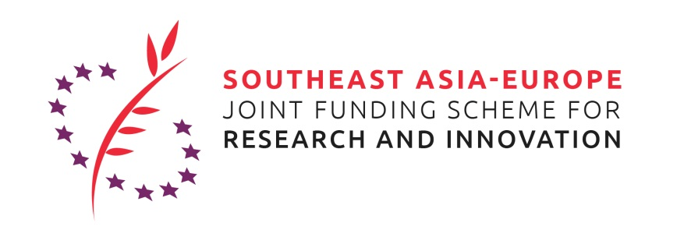

Southeast Asia – Europe Joint Funding Scheme (JFS)
Networking & Matchmaking Event with a Focus on Nanotechnology
at the 14th Joint Conference on Chemistry
10-11 September 2019, Surakarta, Indonesia
Venue: Solo Paragon Hotel & Residence
Meeting Room: TBD
http://jcc.uns.ac.id

GOAL OF THE Networking Event
The SEA-Europe Joint Funding Scheme for Research and Innovation (JFS) is a network of funders from Southeast Asia and Europe which launches Joint Calls for Proposals on an annual basis.
Currently, the 3rd Joint S&T Call for Proposals (Nanotechnologies and Integrated Water Resource Management) and the 4th Joint Innovation Call for Proposals in the two thematic areas of Infectious Diseases (incl. AMR) and Smart Cities are open.
The JFS Networking & Matchmaking Event provides all relevant information about the Joint Funding Scheme and the related activities. The currently open Calls will be presented in detail with a focus on the Joint S&T Call and its thematic area Nanotechnologies.
To support the set-up of strong consortia for the submission of project proposals with high quality, selected European researchers seeking for complementing partner organizations in Southeast Asia will present their institution and project ideas.

TARGET GROUP
Researchers and interested companies related with nanotechnology research

REGISTRATION
Please register for the meeting by 6 September 2019

AGENDA
Match Making Event: 11 September 2019
09:00 am – 13:00 pm
08:30 am | Registration
09:00 am | Welcome / Introduction | UNS
09:05 am | Introduction to the Southeast Asia Joint Funding Scheme | DLR/DIPI
09:12 am | 3rd Joint S&T Call for Proposals | DLR/DIPI
09:30 am | Discussion of questions
09:40 am | Nanotechnologies: Chances for and benefits of bi-regional research cooperation | Senior member of Indonesia Science Academy (tbd)
10:00 am | Presentation of Project Idea 1 | SEA researcher
10:07 am | Presentation of Project Idea 2 | EU researcher
10:14 am | Coffee Break (poster exhibition)
10:30 am | Presentation of Project Idea 3 | SEA researcher
10:37 am | Presentation of Project Idea 4 | EU researcher
10:44 am | Presentation of Project Idea 5 | SEA researcher
10.51 am | Presentation of Project Idea 6 | EU researcher
10.58 am | Presentation of Project Idea 7 | SEA researcher
11.05 am | Presentation of Project Idea 8 | EU researcher
11.12 am | Presentation of Project Idea 9 | SEA researcher
11.19 am | Presentation of Project Idea 10 | EU researcher
11:26 am | Discussion and Summary | Moderated by DLR/DIPI
12:00 pm | Lunch and room for individual discussion | Round table arrangement
Note: potential applicants are urged to display their idea in the poster exhibition during the conference and match making event

