Quark-gluon plasma is the fastest rotating liquid

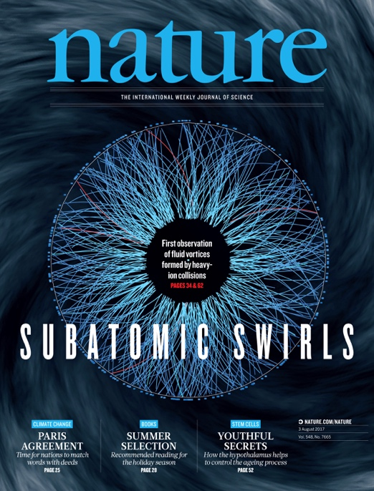

Press Release:

The experiment STAR measured the vorticity of quark-gluon plasma

Collisions of two heavy atomic nuclei at the Relativistic Heavy Ion Collider (RHIC) accelerator in the Brookhaven National Laboratory (BNL) in New York and the Large Hadron Collider (LHC) at the European Organization for Nuclear Research (CERN) in Geneva allow the creation in the laboratory of the conditions dominating in space only a few seconds after the Big Bang. The discovery of the quark gluon plasma (QGP), made at the RHIC accelerator in 2005 by the experiments BRAHMS, PHENIX, PHOBOS and STAR (Nucl. Phys. A757 (2005) 1-283), awakened the interest in a detailed study of the new phase of matter, the most ideal known liquid, existing at temperatures 100,000x higher than the temperature of the Sun’s core. Significant advancement in the mapping of the hydrodynamic properties of QGP was recently made by the experiment STAR (Nature 548 (2017) 62-65), which published the results concerning the vorticity of the plasma. Vorticity (curl of the velocity field) is the rate of the rotation in a continuum and characterises the spiral structure of the flow of liquids. The classical example of vorticity is the rotary motion of the water at the drain outlet of the sink or the rotation of the air at a synoptic scale. In the case of quark-gluon plasma, rotation is a consequence of the momentum transfer between the two colliding cores.
The size of the rotation movement of QGP was determined by measuring the polarization of the Λ particles produced in the collisions of the nuclei of god in the RHIC accelerator. The particle is polarized if its internal moment of momentum (spin) is oriented in the direction of the moment of the momentum of the plasma. The advantage of the Λ particle is that one of its decay products Λ→p+π, the proton (p) flies predominantly in the direction of the spin Λ, which can be easily measured. The result acquires by the experiment STAR proved that the plasma rotates with the frequency of 10²² times per second. This small “supertornado” is thus the fastest rotating liquid observed.
“The discovery of the global polarization of the Λ particles in a non-central collisions of heavy nuclei opens new paths in the study of the hottest, the least viscous, and as now shown the most swirling fluids created under laboratory conditions”, doplňuje doc. Michal Šumbera from the Nuclear Physics Institute of the CAS, v.v.i. “Two electrically charged nuclei flying against one another creating according to the Biot-Savarat Law on the site of the collision an extremely strong, albeit only very shortly existing, magnetic field¹. The theoretically anticipated value of the magnetic field created in the collision of two nuclei of gold in the RHIC accelerator is 10¹⁸ Gauss, which is 1000x times more than with the strongest known sources of magnetic fields – of neutron stars called magnetars. Like with nuclear magnetic resonance, when the spins of the protons and neutrons of the nucleus are directed into the outer magnetic field, it is possible from the particle polarization of the Λ particles to determine the magnitude of the field of the induced by the colliding nuclei. The results acquired now by the experiment STAR are the base for future more precise measurements, which will make it possible to determine its magnitude” adds Doc. (Associate Professor) Šumbera.

A summary of the current state of this research can be found in the synopsis of R. Pasechnik and M. Šumbera, Phenomenological Review on Quark–Gluon Plasma: Concepts vs. Observations, Universe 3, no. 1, 7 (2017), https://arxiv.org/abs/1611.01533.
The experiment STAR (http://www.star.bnl.gov) at the RHIC accelerator in BNL has been participated in by scientists and students from the NPI of the CAS, v.v.i. and from the Faculty of Nuclear Sciences and Physical Engineering. of CTU in Prague since 2000.
The article can be freely downloaded at the address https://arxiv.org/abs/1701.06657.

